**9. Create a React Application named “cricketapp” with the following components:**

**App.js**

import React from 'react';

import ListofPlayers from './ListofPlayers';

import Scorebelow70 from './Scorebelow70';

import OddPlayers from './OddPlayers';

import EvenPlayers from './EvenPlayers';

import ListofIndianPlayers from './ListofIndianPlayers';

function App1() {

  const flag = true;

  const players = [

    { name: "Fazil", score: 50 },

    { name: "Karthick", score: 70 },

    { name: "Ambu", score: 40 },

    { name: "Adhil", score: 61 },

    { name: "Basha", score: 61 },

    { name: "Nazhi", score: 95 },

    { name: "Amar", score: 100 },

    { name: "Joseph", score: 84 },

    { name: "Jadeja", score: 64 },

    { name: "Raina", score: 75 },

    { name: "Rohit", score: 80 },

  ];

  const IndianTeam = ["Sachin1", "Dhoni2", "Virat3", "Rohit4", "Yuvaraj5", "Raina6"];

  const IndianPlayers = ["Mr. First Player", "Mr. Second Player", "Mr. Third Player"];

  const T20players = ["Mr. Fourth Player", "Mr. Fifth Player", "Mr. Sixth Player"];

  const mergedPlayers = [...IndianPlayers, ...T20players];

  if (flag === true) {

    return (

      <div>

        <h1>List of Players</h1>

        <ListofPlayers players={players} />

        <hr />

        <h1>List of Players having Scores Less than 70</h1>

        <Scorebelow70 players={players} />

      </div>

    );

  } else {

    return (

      <div>

        <h1>Indian Team</h1>

        <h2>Odd Players</h2>

        <OddPlayers team={IndianTeam} />

        <hr />

        <h2>Even Players</h2>

        <EvenPlayers team={IndianTeam} />

        <hr />

        <h1>List of Indian Players Merged:</h1>

        <ListofIndianPlayers IndianPlayers={mergedPlayers} />

      </div>

    );

  }

}

export default App1;

**ListOfPlayers.js**

import React from 'react';

function ListofPlayers({ players }) {

  return (

    <div>

      {players.map((item, index) => (

        <li key={index}>Mr. {item.name} <span>{item.score}</span></li>

      ))}

    </div>

  );

}

export default ListofPlayers;

**ScoreBelow70.js**

import React from 'react';

function Scorebelow70({ players }) {

  const filtered = players.filter(player => player.score <= 70);

  return (

    <div>

      {filtered.map((item, index) => (

        <li key={index}>Mr. {item.name} <span>{item.score}</span></li>

      ))}

    </div>

  );

}

export default Scorebelow70;

**OddPlayers.js**

import React from 'react';

function OddPlayers({ team }) {

  const [first, , third, , fifth] = team;

  return (

    <div>

      <li>First: {first}</li>

      <li>Third: {third}</li>

      <li>Fifth: {fifth}</li>

    </div>

  );

}

export default OddPlayers;

**EvenPlayers.js**

import React from 'react';

function EvenPlayers({ team }) {

  const [, second, , fourth, , sixth] = team;

  return (

    <div>

      <li>Second: {second}</li>

      <li>Fourth: {fourth}</li>

      <li>Sixth: {sixth}</li>

    </div>

  );

}

export default EvenPlayers;

**ListOfIndiaPlayers.js**

import React from 'react';

function ListofIndianPlayers({ IndianPlayers }) {

  return (

    <div>

      {IndianPlayers.map((player, index) => (

        <li key={index}>{player}</li>

      ))} </div>

  );}

export default ListofIndianPlayers;

**Output:**

**Flag == True**

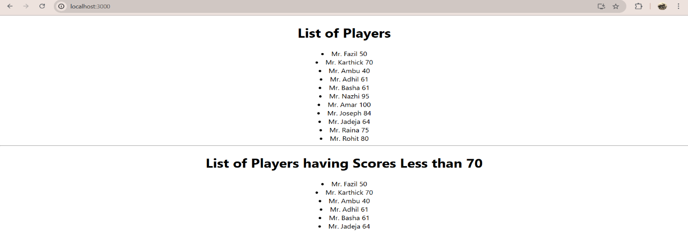

**Flag == False**

